“Challenging Times – One Year On”
Working together to deliver effective rural health services

Friday 18th October 2013
Sandy Park Conference Centre
Sandy Park Way, Exeter, Devon, EX2 7NN

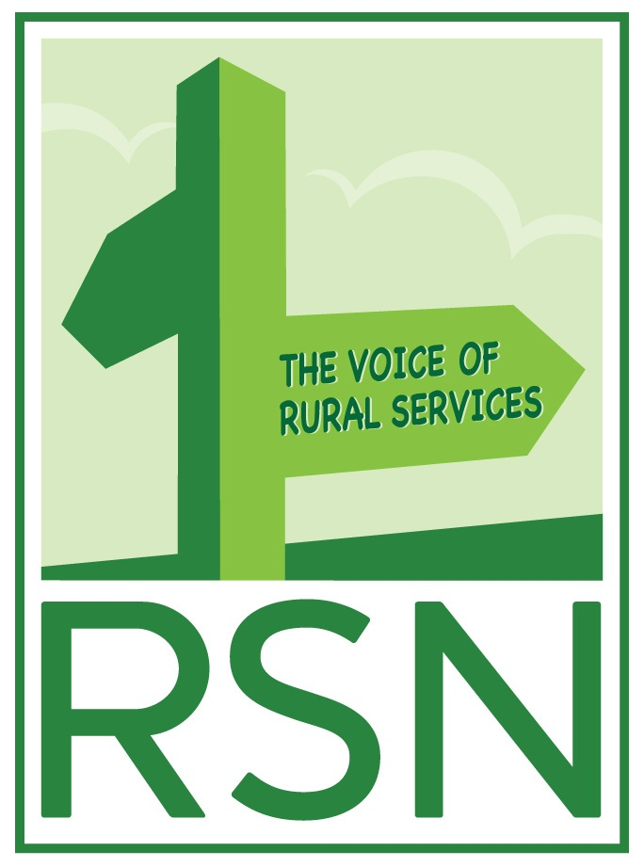

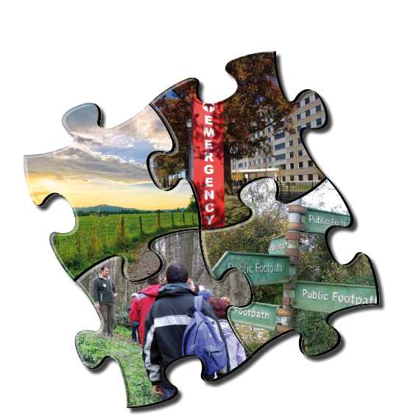


9.00 am | Arrival - coffee and registration
9.30 am | Welcome  Dr Virginia Pearson, Director of Public Health, Devon County Council
9.35 am | Introduction to the Day  Chair, Graham Stuart MP, Beverley & Holderness, Chair, Rural Services All Party Parliamentary Group and Co-Founder of the Rural Fair Shares Campaign
9.45 am | Keynote Address; What England can learn from Scotland’s experience in effectively deploying telehealth to rural communities  Professor James Ferguson, Clinical Lead, Scottish Telehealth Centre
10.15 am | BT and 3 Million Lives – One Year On – an overview of the national NHS telehealth initiative and the new related BT project in Cornwall  Angela Single, Clinical Director, BT Global
10.45 am | Bringing Healthcare Home – outline of a district general hospital’s experience in Yorkshire providing healthcare in the home setting  Ann Wagner, Director of Strategy and Business Development, Airedale NHS Foundation Trust
11.15 am | Refreshments and networking
11.30 am | Competition or Collaboration? Which works best for small district general hospitals - is integration the answer? – a personal view  Jo Newton, Former Chair of a cluster PCT in Gloucestershire and Shropshire
12.00 pm | Integrated Commissioning – providing safe and effective paediatric services for a rural area  Dr Deb Lee, Consultant Paediatrician/Dr Peter Weaving, GP, Clinical Director – North Cumbria Universities Hospital Trust
12.30 pm | Question and Answer Session for morning speakers
1.00 pm | Lunch and networking
1.40 pm | Chair, Graham Stuart MP - Chair, Rural Services All Party Parliamentary Group
1.45 pm | Workshops - First Sessions:  - Rural Proofing Toolkit update  DEFRA – Audrey Roy  - Neighbourhood Health Watch – helping rural communities to help themselves  Dr Peter Aitken, Devon Partnership NHS Trust  - Libraries and Health Project in Somerset  Dr Malcolm Rigler, GP and Heather Eardley, Patients Association  - Recovery College  Dr Julie Repper, Helen Brown, Scott Pomberth, Angela Mulholland, Nottinghamshire Healthcare Trust – Mental Health Recovery and Life Care Support  - Improving Health and Wellbeing in Rural Areas – lessons from Healthy Living Centres  Mary Nisbett, Director, Westbank Healthy Living Centre, Exminster  - “Why don’t Rural Areas get their fair share of health funding?” – an update following the Health & Social Care Act 2012 reforms and implications for the future  Professor Sheena Asthana, Plymouth University
2.40 pm | Tea
3.00 pm | Workshops Second Session (repeated as above)
4.00 pm | Plenary and Workshop Feedback  Graham Stuart MP, Chair, with input from the workshop leaders
4.20 pm | Closing Address and Next Steps  Professor Mike Cooke CBE, Chief Executive Officer, Nottinghamshire Healthcare Trust
4.30 pm | Conference Closes

The Rural Services Network

The Rural Services Network (RSN) seeks to maintain and, where possible, improve rural services in England.

The Rural Service Network:

• makes representations on issues affecting rural service
• forms a network between service providers and across sectors
- establishes and broadcasts rural best practice

The Network comprises over 100 Local Authorities (SPARSE Rural) and 110 Non Local Authority Service Bodies (Rural Services Partnership Ltd) and has Associate (Significant Rural) and Affiliate (Private Sector) Groups. Adequate recognition of the additional cost of provision of rural services in the countryside is an important issue for the Network. The Network was instrumental in the formation of the All Party Parliamentary Group on Rural Services in Parliament. It involves 66 Parliamentarians.

The Network is believed to be unique in Europe and seeks to foster constructive debate on all English rural service issues. Its weekly email newsletter on rural news and comment goes out to some 45,000 people in service and consumer groups. At grass roots level, we have a Community Group comprising 4,000 Local Councils, 3,000 Schools and 500 other rural organisations. “Calls for Evidence” and questionnaires seek to provide operating experience, best practice and collective rural viewpoints.

This information is disseminated and available through our widely respected website (www.rsnonline.org.uk). The group provides services through membership subscription and contract revenue and does not seek or receive any Government grant.

In 2012 the RSN established the Rural Health Network. Further details are available at:
www.rsnonline.org.uk/virtual-authority/health-landing-page

Devon County Council

The health and wellbeing of people living in rural areas is a high priority for Devon County Council and its partners as Devon is the third largest county in England. It is also the seventh most sparsely populated county, with a few large settlements and a dispersed rural population, covering Dartmoor National Park and part of Exmoor National Park. Over 90% of its land area is defined as “rural” (settlements <10,000). Of the approximately 750,000 people living in Devon (excluding Plymouth and Torbay), 52% live in rural areas. This figure for Devon is significantly higher than the regional (34%) and national (19%) rural averages with South Hams, West Devon, Mid Devon and Torridge having the highest proportions of the population living in rural areas.

The Devon Joint Strategic Needs Assessment has identified that the real challenges faced by many people living in rural areas include:

• deprivation (including pockets of hidden deprivation)
• a growing ageing population
• small, sparsely distributed populations
• changing population patterns, including outward migration of young people
• social isolation and social exclusion
• lack of affordable housing and fuel poverty
• poor infrastructure, access issues and a lack of health and related services
• a shrinking skilled workforce
• specific health needs associated with some population subgroups

It is against this backcloth that Devon County Council, working closely with eight district, borough and city councils and two Clinical Commissioning Groups, seeks to commission services which offer best value and have the greatest positive impact on the health and wellbeing of local people.

Rural Health Network Event
Challenging Times – One Year On
Working together to deliver effective rural health services
Friday 18th October 2013
Sandy Park Conference Centre, Exeter

Delegate Booking Form
Your Details (1st Delegate) |  | 2nd Delegate
Dr Mr Mrs Miss Ms (Please circle) |  | Dr Mr Mrs Miss Ms (Please circle)
Name: |  | Name:
Surname: |  | Surname:
Job Title: |  | Job Title:
Organisation: |  | Organisation:
Address: |  | Address:
Postcode: |  | Postcode:
Telephone Number: |  | Telephone Number:
Email address: |  | Email address:
Workshop Choices:
 | 1st choice | 2nd choice
Workshop Session One 1.45 pm
Workshop Session Two 3.00 pm

Payment by invoice:
Name:
Organisation:
Address:
Postcode: Purchase Order Number: (if applicable)

Do you have any dietary requirements?
Do you have any other special requirements?
Conference fee: First Delegate: £150 + VAT Additional delegate fee: £75 + VAT
This fee includes membership to the Rural Health Network
Confirmation of Booking: All places will be confirmed by email, pending availability. Please contact us if you do not receive any confirmation 10 days after submitting your booking.
All enquires to: Nick Payne, Rural Services Network - 01822 813693
Please complete and return form to:
- Post: Nick Payne, Rural Health Network Event, c/o Rural Services Network, Kilworthy Park, Drake Road, Tavistock, PL19 0BZ
- Email: nick.payne@sparse.gov.uk
- Fax: 01822 813634 – please mark form for the attention of the Rural Services Network
CLOSING DATE FOR REGISTRATIONS: 13th SEPTEMBER 2013

